**PROGRAMMNG FUNAMENTAL ASSINGMENT NO2:**

Performed By : ALI ASAD

SAP ID: 65320

SECTION: SE 1-2

TO: SIR SHAHZAD AHMAD

**Q1: You are required to write a program for a fast food/snack parlor. Your program shows the following menu to the user**

**M** Meals

**B** Beverages

Prompt the user to enter m/M to buy a meal and B or b for a Beverage. If the user chooses to buy a meal then you should display the following

1. Burger Rs. 350

2. Roll Paratha Rs. 190

3. Spaghetti Rs. 22

But if the user chose beverage from the first menu, then following items are displayed.

1. Coffee Rs 150/cup

2. Fresh Juice Rs. 340/glass

3. Green Tea Rs. 75/cup

Read user’s choice (1, 2 or 3), ask quantity of the selected item. Now compute and display the total bill. Add a 3.5% tax on the total Bill.

ANSWER

1stScenario:

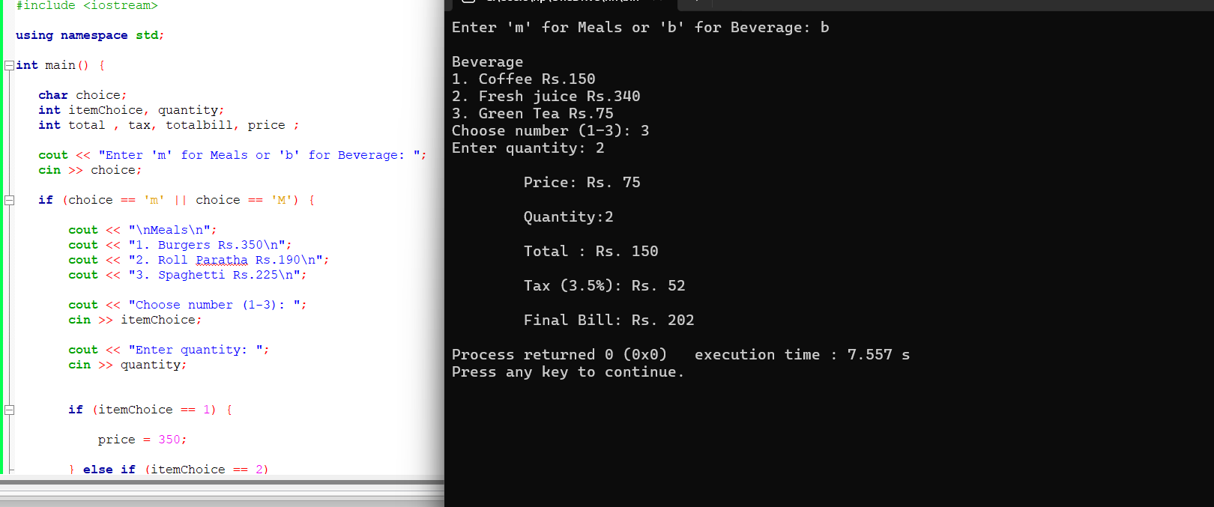

2ndScenario:

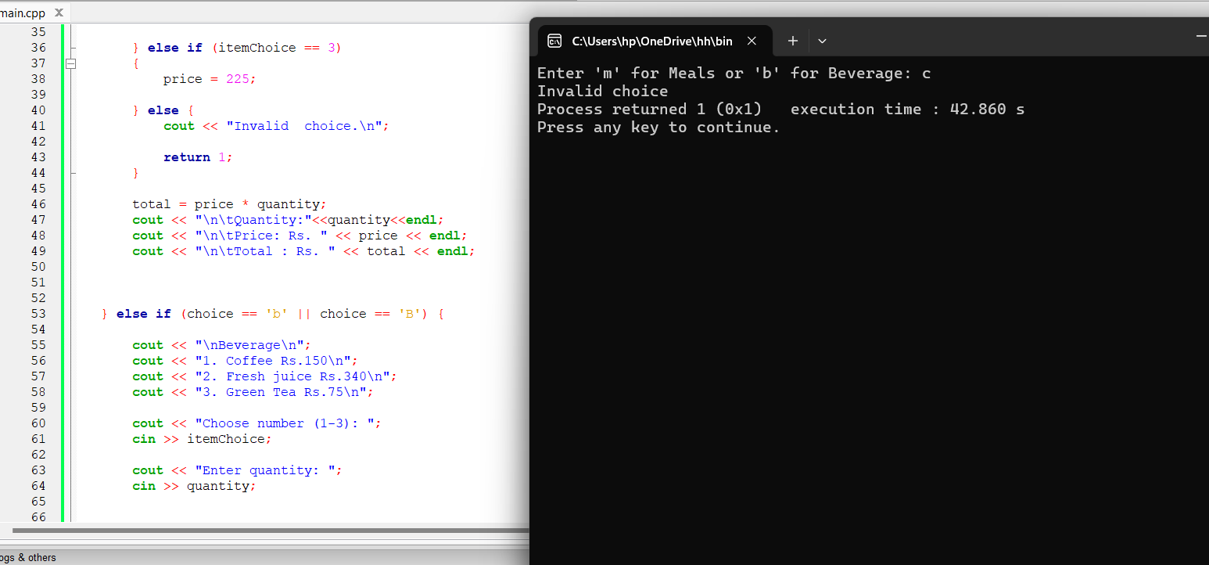

3rdScenario:

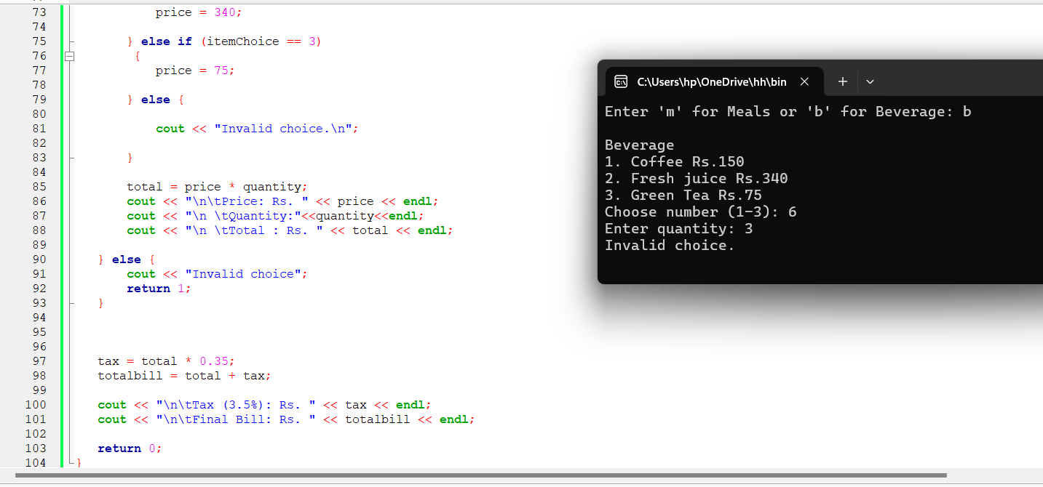

**Q2**: **Because of the on-going power shortage, the government has decided to revise the electricity charges in hope of getting economical usage by consumers. The revised rules are as follows: Per unit charge range**

**Per unit charge range**

|  |  |
| --- | --- |
| Rs 10 | First 80 units |
| Rs 25 | 81 - 150 |
| Rs 40 | Next 200 units |
| Rs 90 | Beyond that |

ANSWER

1stScenario:

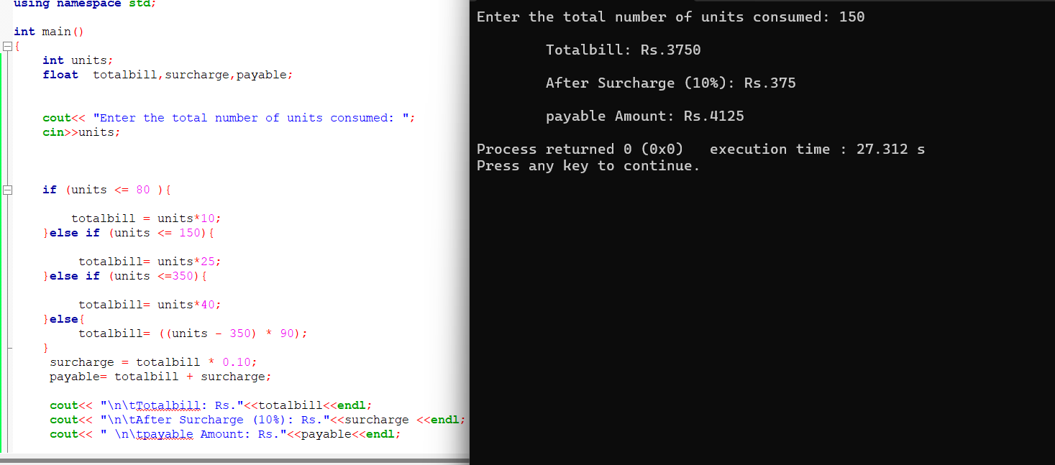

2ndScenario:

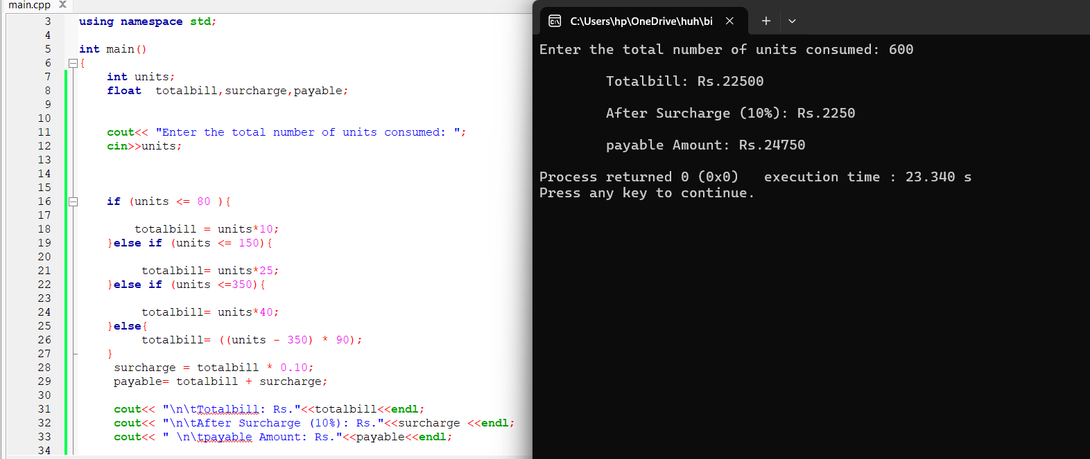

**Q3**: **Write a program that performs the following conversion**

1. Feet to inches

2. Inches to Feet

3. Yards to meters

4. Meters to yard

It prompts the user to select an option and provide the value to be converted. It then shows the result (Find the appropriate conversion formulas yourself).

ANSWER

1stScenario:

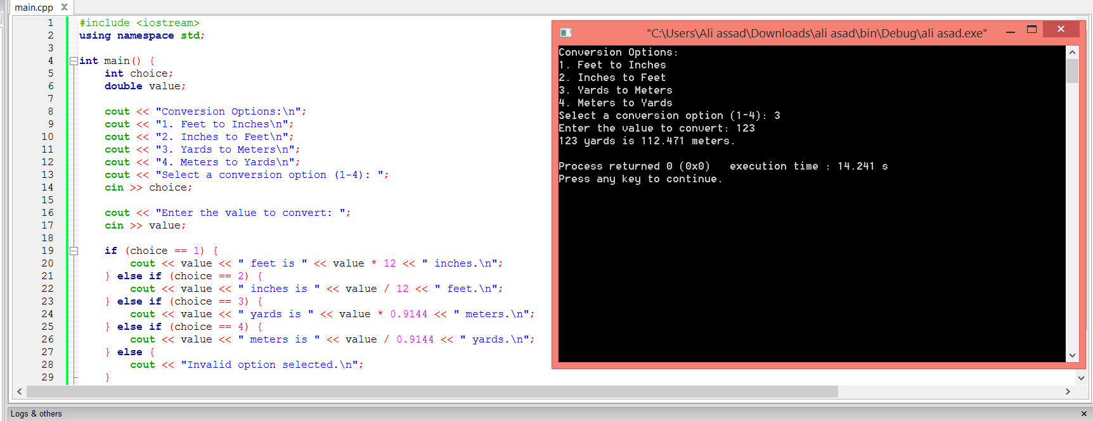

2ndScenario:

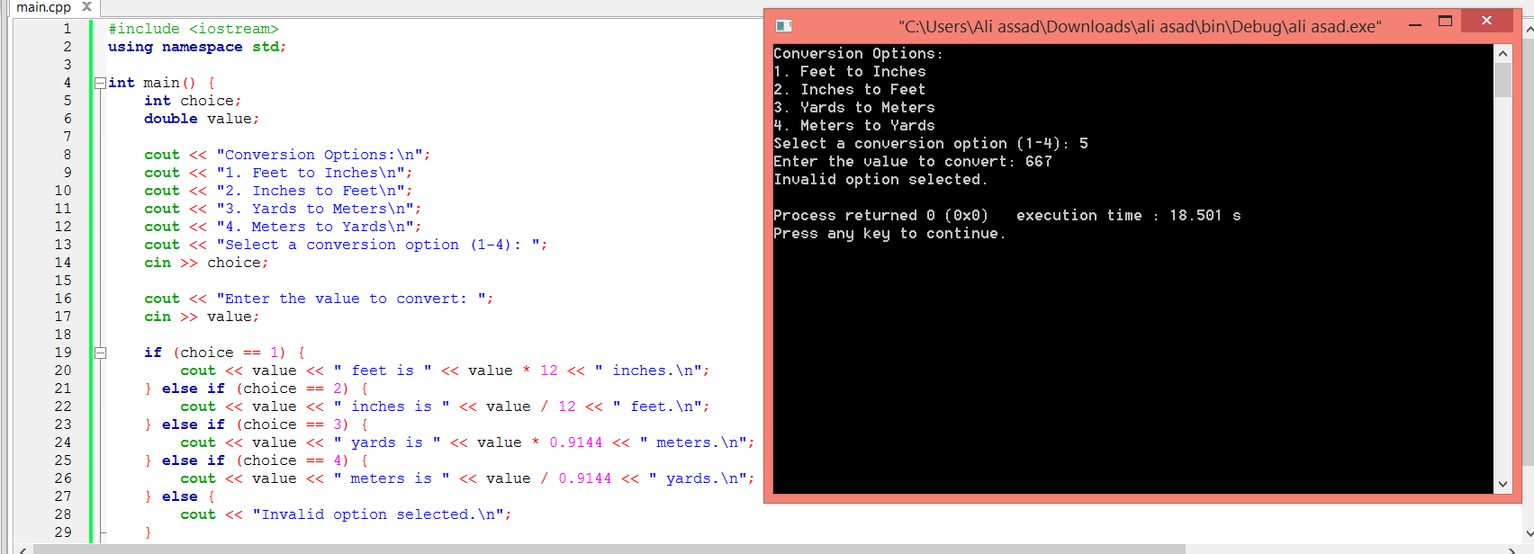

**Q4: You have been selected by the Dean FC to develop a program that would assist in the fee calculation during the course registration days. The department has also decided to offer fee waivers to students if they fulfill the defined criteria. Following are the eligibility criteria for fee waivers • A student with a CGPA above 3.6 can get a 10% talent scholarship**

• All girl students in semester 6 or higher with CGPA above 3 can get 5% fee waiver

• Students who have completed 100 credits will get 25% waiver only if they have registered at least 14 credits for the current semester

• No waiver is applicable if the CGPA of a student is below 2.

Students can qualify for more than 1 category of waivers Your program will read the following from the use

Your program will read the following from the user

1. CMS # 2. Semester number

3. CGPA

4. No of credits completed

5. No of credits registered for current semester

6. Gender of the student

. Calculate the tuition fee @ 5500/ credit registered. Also 2000 exam fee is charged and 1000 registration fee. The waiver applies only on the tuition fee. Print the Challan Form as follows

CMS #:

CPGA:

SEMSTER #:

CREDITS REGISTERED:

TOTAL CREDITS COMPLETED:

TOTAL TUITION FEE:

WAIVER:

NET PAYABLE TUITION FEE:

EXAMINATION FEE:

REGISTRATION FEE:

TOTAL PAYABLE AMOUNT:

ANSWER

**1st scenario:**

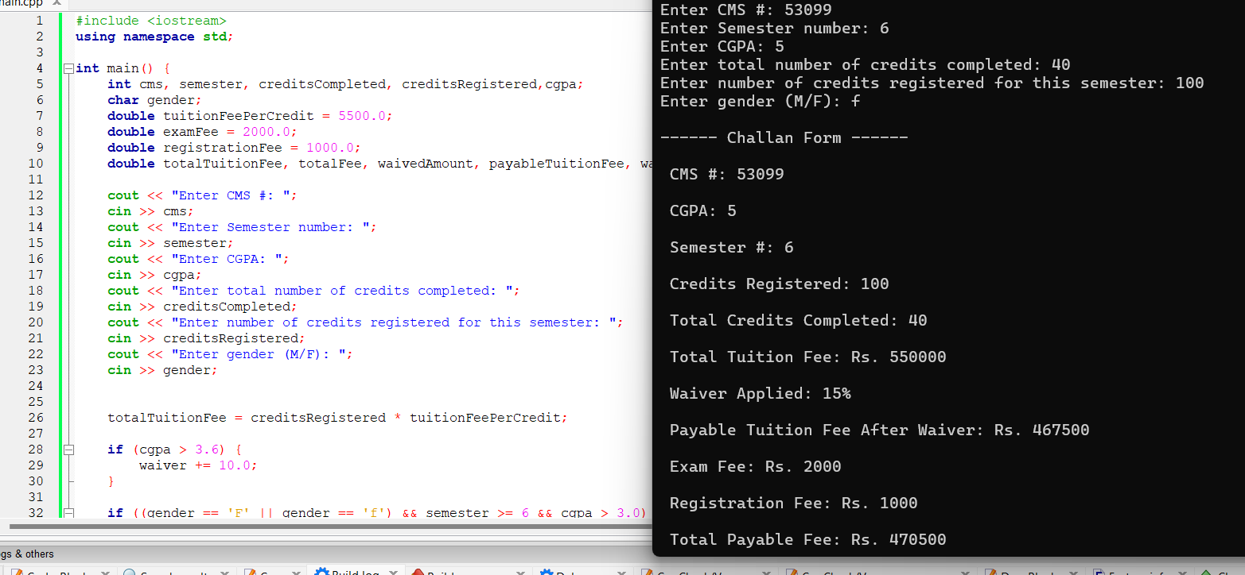

**2nd scenario:**

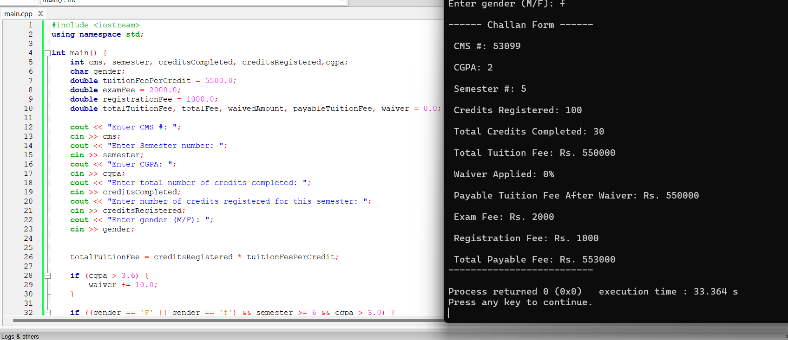

BONUS PART

